Testing, Linux and Servers Assignments with Screenshots

Task1: System Monitoring Setup

CPU, Memory and Load using Top command

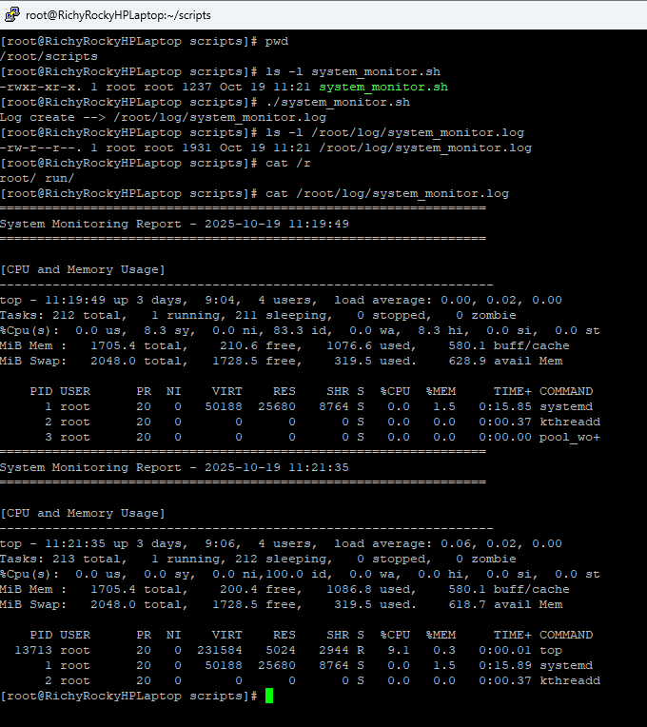

Disk Usage Summary using df command

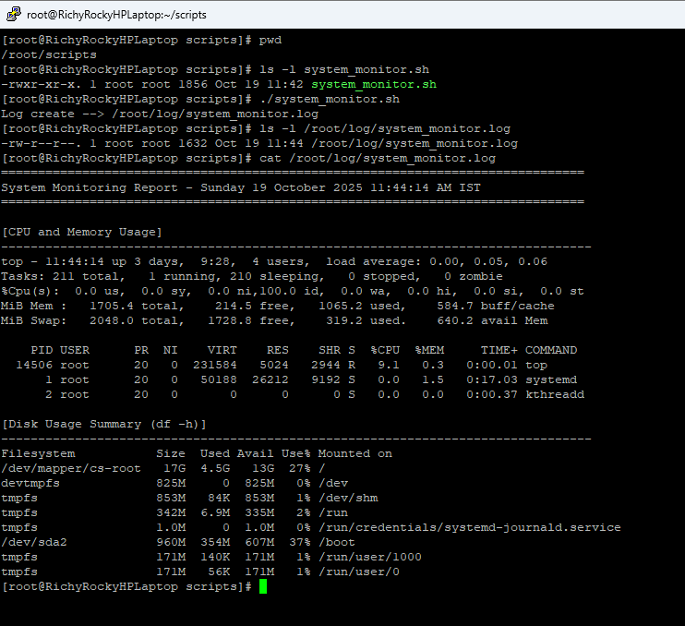

Directory Disk Usage for the folders – “/home; /var; /opt” using “du” command

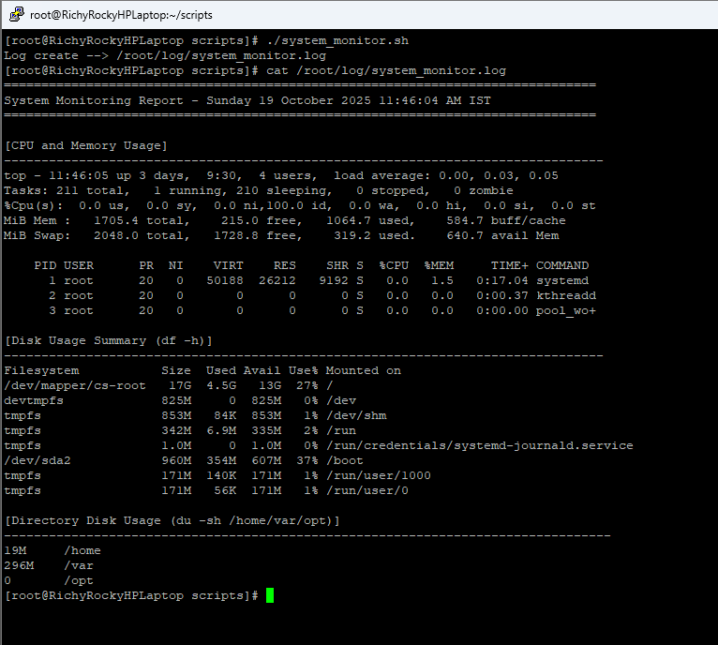

Top Resource – Intensive Processes using **ps** command

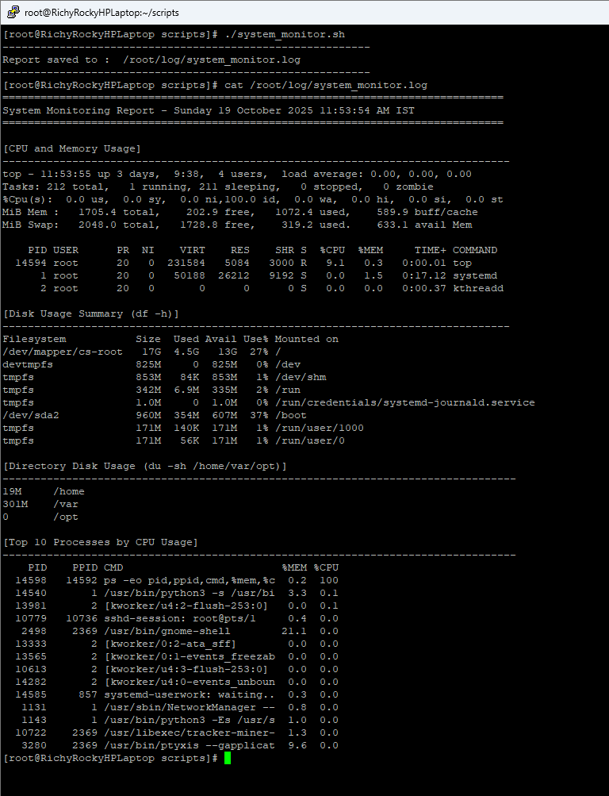

Top 10 Processes by Memory Usage using **ps** command

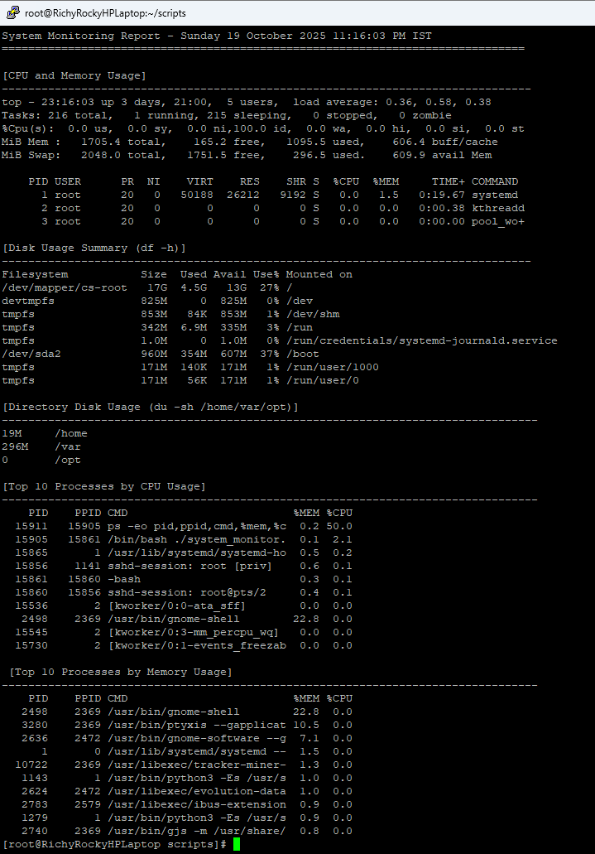

README.md file

# Testing, Linux and Servers Assignment

This assignment covers the testing, Linux and Servers. It has total 3 tasks to develop:
- Task 1: System Monitoring Setup
- Task 2: User Management and Access Control
- Task 3: Backup Configuration for Web Servers

## Task 1: System Monitoring Setup

### Overview
```
This script helps monitor CPU, memory, process, and disk usage for development servers.
It logs system metrics to `/var/log/system_monitor.log` and provides visibility for troubleshooting and performance planning.
```

### Objectives
```
- Ensure visibility into system performance (CPU, memory, and processes)
- Monitor disk usage and capacity
- Identify top resource-consuming processes
- Maintain system health awareness for developers
```

### Prerequisites
```
Ensure the following are installed:
- **htop**
- **nmon**
- Core system tools: `df`, `du`, `ps`, `top`
```

### Script Execution and View log file

```bash
**Script Folder** - /root/scripts/system_monitor.sh
**Log Folder** - /root/log/system_monitor.log
>Chmod 755 /root/scripts/system_monitor.sh
>./system_monitor.sh
>cat /root/log/system_monitor.log
```
### Example Output
```
===============================================================================
System Monitoring Report - Sunday 19 October 2025 11:58:10 AM IST
===============================================================================

[CPU and Memory Usage]
--------------------------------------------------------------------------------
top - 11:58:11 up 3 days, 9:42, 4 users, load average: 0.00, 0.00, 0.00
Tasks: 211 total, 1 running, 210 sleeping, 0 stopped, 0 zombie
%Cpu(s): 0.0 us, 0.0 sy, 0.0 ni,100.0 id, 0.0 wa, 0.0 hi, 0.0 si, 0.0 st
MiB Mem : 1705.4 total, 201.9 free, 1071.3 used, 591.9 buff/cache
MiB Swap: 2048.0 total, 1728.8 free, 319.2 used. 634.1 avail Mem

PID USER PR NI VIRT RES SHR S %CPU %MEM TIME+ COMMAND
1 root 20 0 50188 26212 9192 S 0.0 1.5 0:17.18 systemd
2 root 20 0 0 0 0 S 0.0 0.0 0:00.37 kthreadd
3 root 20 0 0 0 0 S 0.0 0.0 0:00.00 pool_wo+

[Disk Usage Summary (df -h)]
--------------------------------------------------------------------------------
Filesystem Size Used Avail Use% Mounted on
/dev/mapper/cs-root 17G 4.5G 13G 27% /
devtmpfs 825M 0 825M 0% /dev
tmpfs 853M 84K 853M 1% /dev/shm
tmpfs 342M 6.9M 335M 2% /run
tmpfs 1.0M 0 1.0M 0% /run/credentials/systemd-journald.service
/dev/sda2 960M 354M 607M 37% /boot
tmpfs 171M 140K 171M 1% /run/user/1000
tmpfs 171M 56K 171M 1% /run/user/0

[Directory Disk Usage (du -sh /home/var/opt)]
---------------------------------------------------------------------------------
19M /home
305M /var
0 /opt

[Top 10 Processes by CPU Usage]
---------------------------------------------------------------------------------
PID PPID CMD %MEM %CPU
14619 14613 ps -eo pid,ppid,cmd,%mem,%c 0.2 100
14540 1 /usr/bin/python3 -s /usr/bi 3.3 0.1
10779 10736 sshd-session: root@pts/1 0.4 0.0
2498 2369 /usr/bin/gnome-shell 21.1 0.0
13333 2 [kworker/0:2-ata_sff] 0.0 0.0
14608 2 [kworker/0:0-events] 0.0 0.0
13565 2 [kworker/0:1-events_power_e 0.0 0.0
10613 2 [kworker/u4:3-events_unboun 0.0 0.0
14282 2 [kworker/u4:0-events_unboun 0.0 0.0
1131 1 /usr/sbin/NetworkManager -- 0.8 0.0
\[Top 10 Processes by Memory Usage]
---------------------------------------------------------------------------------
PID PPID CMD %MEM %CPU
2498 2369 /usr/bin/gnome-shell 21.1 0.0
3280 2369 /usr/bin/ptyxis --gapplicat 9.6 0.0
2636 2472 /usr/bin/gnome-software --g 7.1 0.0
14540 1 /usr/bin/python3 -s /usr/bi 3.3 0.1
1 0 /usr/lib/systemd/systemd -- 1.5 0.0
10722 2369 /usr/libexec/tracker-miner- 1.3 0.0
1143 1 /usr/bin/python3 -Es /usr/s 1.0 0.0
2624 2472 /usr/libexec/evolution-data 1.0 0.0
2783 2579 /usr/libexec/ibus-extension 0.9 0.0
1279 1 /usr/bin/python3 -Es /usr/s 0.9 0.0
```
Automate with Cron
To run every 30 minutes:
sudo crontab -e
Add:
*/30 * * * * /usr/local/bin/system_monitor.sh

Task 2: User Management and Access Control

Objective: Set up user accounts and configure secure access controls for the new developers.

Scenario:

Two new developers, Sarah and Mike, require system access.
Each developer needs an isolated working directory to maintain security and confidentiality.
Security policies must ensure proper password management and access restrictions.

Requirements:

- Create user accounts for Sarah and Mike with secure passwords.
- Set up dedicated directories:
Sarah: /home/Sarah/workspace
Mike: /home/mike/workspace
- Ensure only the respective users can access their directories using appropriate permissions.
- Implement a password policy to enforce expiration and complexity (e.g., passwords expire every 30 days).

Create user account for sarah

[root@RichyRockyHPLaptop home]# whoami
root
[root@RichyRockyHPLaptop home]# id sarah
id: ‘sarah’: no such user
[root@RichyRockyHPLaptop home]# id mike
id: ‘mike’: no such user
[root@RichyRockyHPLaptop home]# sudo useradd -m sarah
[root@RichyRockyHPLaptop home]# sudo passwd sarah
New password:
BAD PASSWORD: The password is shorter than 8 characters
Retype new password:
passwd: password updated successfully
[root@RichyRockyHPLaptop home]# sudo useradd -m mike
[root@RichyRockyHPLaptop home]# sudo passwd mike
New password:
BAD PASSWORD: The password is shorter than 8 characters
Retype new password:
passwd: password updated successfully
[root@RichyRockyHPLaptop home]# id sarag
id: ‘sarag’: no such user
[root@RichyRockyHPLaptop home]# id sarah
uid=1004(sarah) gid=1006(sarah) groups=1006(sarah)
[root@RichyRockyHPLaptop home]# id mike
uid=1005(mike) gid=1007(mike) groups=1007(mike)
[root@RichyRockyHPLaptop home]#

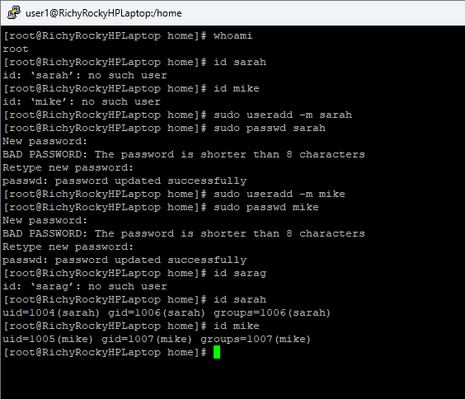

User sarah has been added
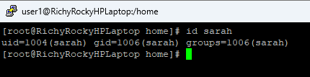

Sarah home directory /home/sarah
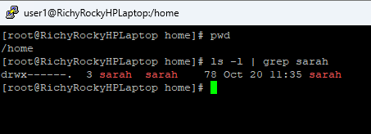

User mike has been added
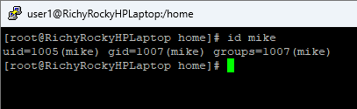

Mike home directory - /home/mike
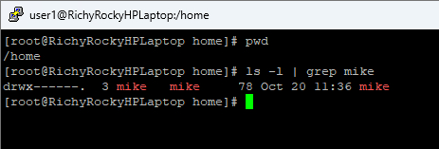

Sarah dedicated directory - /home/sarah/workspace

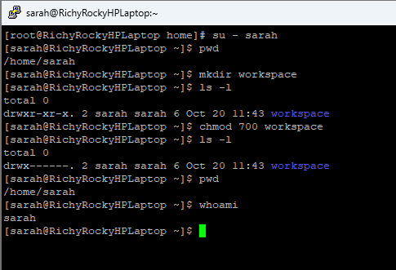

Mike dedicated directory - /home/mike/workspace

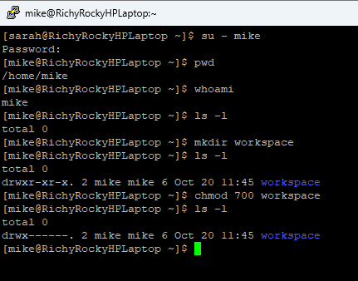

Sarah trying to access Mike’s directory and getting **permission denied**

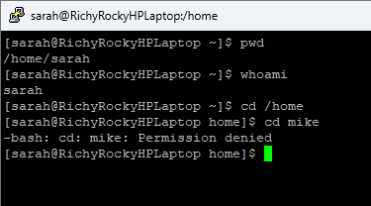

Mike trying to access Sarah’s directory and getting **permission denied**

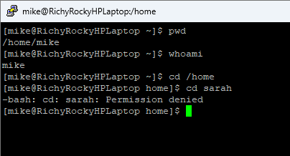

Password policy for Sarah account

Existing Password policy for Sarah

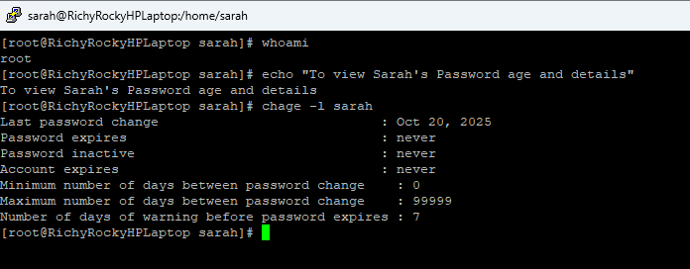

After changing the password policy (expiration) for Sarah

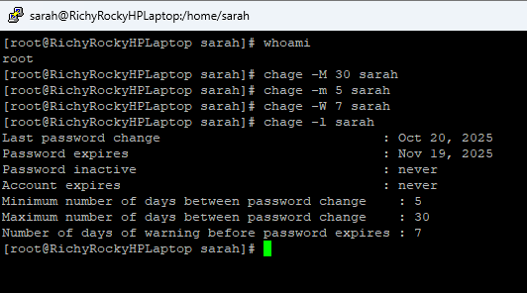

Password policy for Mike account

Existing Password policy for Mike

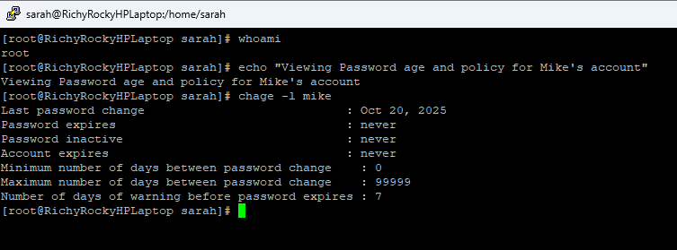

After changing the password policy (expiration) for Mike account

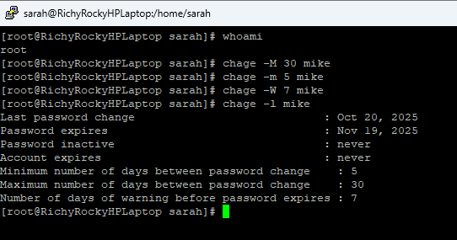

Password Complexity

/etc/pam.d/system-auth

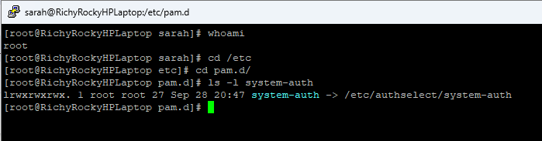

Default password complexity

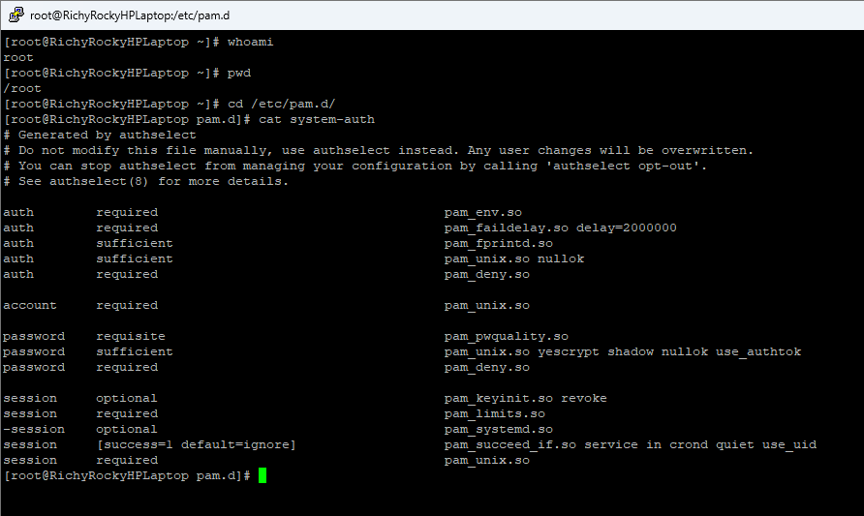

To enforce password quality rules –
Add the below parameters in /etc/pam.d/system-auth file
```
password requisite pam_pwquality.so retry=3 minlen=12 maxrepeat=3 ucredit=-1 lcredit=-1 dcredit=-1 ocredit=-1 difok=4 reject_username enforce_for_root
```
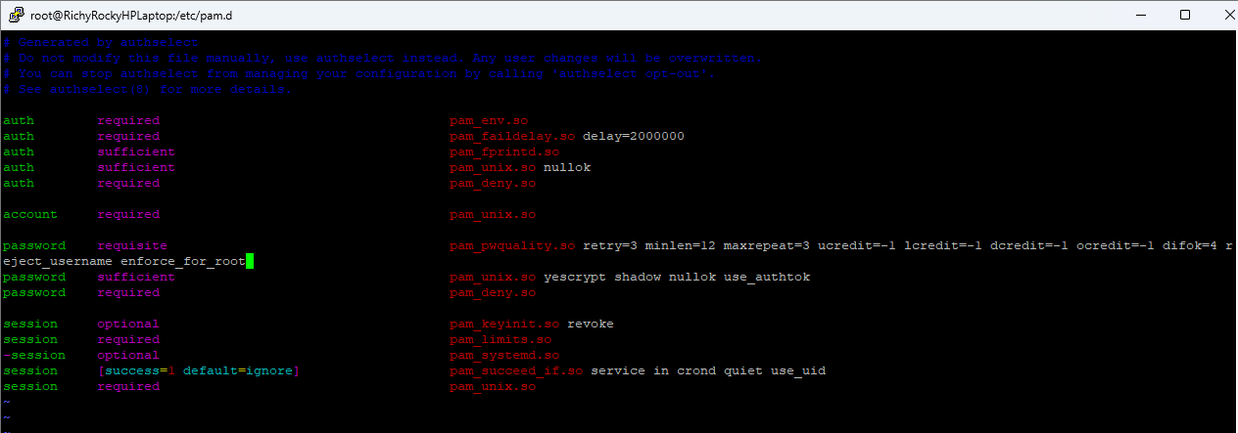

After adding the above parameters for Password Complexity

